**Author: Charlotte Watson**

**Type 1 Diabetes Mellitus**

**Definition**

Diabetes mellitus is a metabolic disorder in which the body’s ability to produce or respond to insulin is impaired, resulting in elevated blood glucose (blood sugar) levels.

The medical term for high blood glucose levels is hyperglycaemia.

Diabetes mellitus comes from the Greek word “*diabetes”* meaning to pass through, and the Latin word “*mellitus”* meaning sweet.

This makes sense as sweet glucose ‘passes through’ the body and into the urine in diabetes mellitus.

Diabetes mellitus can be classified into 2 main types:

1. Type 1 Diabetes Mellitus
2. Type 1 Diabetes Mellitus

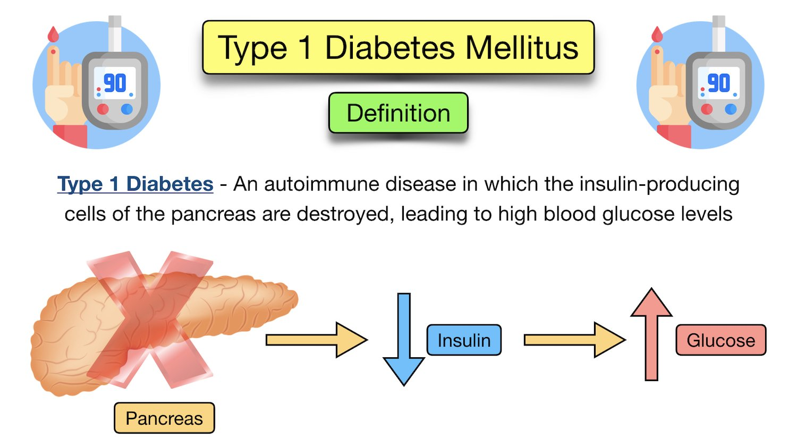

Diabetes Mellitus Definition: Type 1 diabetes is an autoimmune disease in which the insulin-producing cells of the pancreas are destroyed, resulting in little to no insulin production and elevated blood glucose levels.

**Symptoms of Type 1 Diabetes**

As previously mentioned, type 1 diabetes is a condition in which the pancreas produces little to no insulin, resulting in high blood glucose levels.

Many cells require insulin for glucose uptake.

In other words, insulin helps transport glucose from the blood and into cells (see insulin function below).

Once inside the cell, glucose can then be used as energy or fuel for the cell.

Without insulin, glucose remains in the blood and blood glucose levels increase as a result.

The elevated blood glucose levels, along with the inability of cells to take up glucose, results in a number of symptoms.

The onset of symptoms is generally very rapid, occurring in just days to weeks.

**Signs and symptoms of type 1 diabetes include:**

* Weight loss
* Polyuria (Increased urine output)
* Frequent urination
* Polydipsia (Increased thirst)
* Dry mouth
* Fatigue and weakness
* Polyphagia (Increased hunger or appetite)
* Blurred vision
* Tachycardia (Fast heart rate)

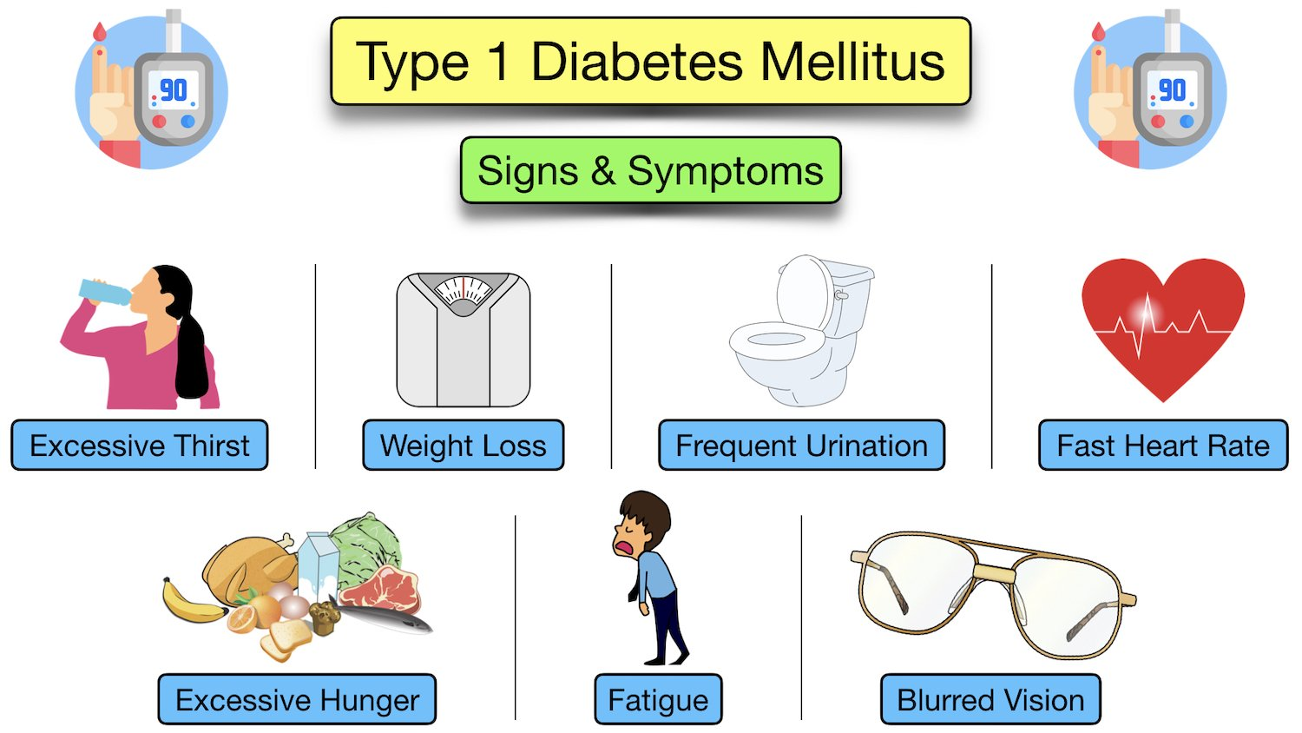

**What Causes Type 1 Diabetes?**

The cause of type 1 diabetes development is not yet known.

However, there are several theories to the cause:

* **Infections**
  + It is theorized that type 1 diabetes could be triggered by infections such as coxsackievirus
* **Autoantibodies**
  + Another theory links type 1 diabetes to autoantibodies against beta cell antigens
* Beta cells are responsible for producing insulin, and the autoantibodies destroy the beta cells
* However, these autoantibodies are only present in the blood of 70-80% of patients, so it is not conclusive whether this relationship is causative

Genetics:

There may also be a genetic link, with a strong association between type 1 diabetes and the presence of HLA-DR3 and HLA-DR4 antigens on chromosome 6

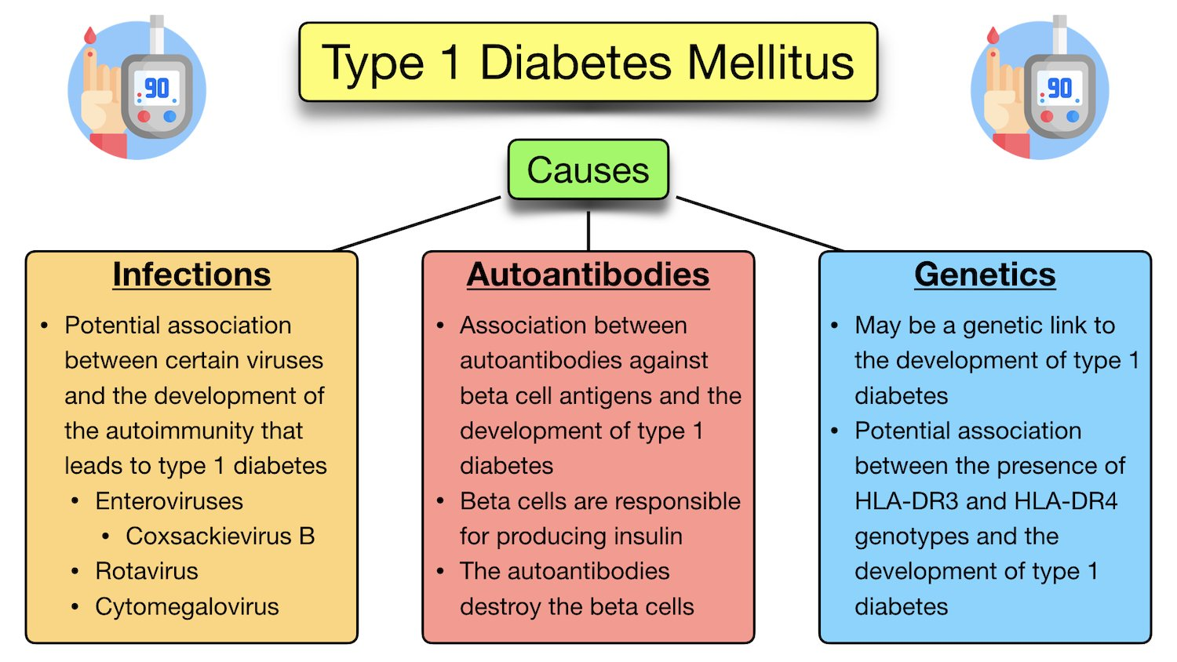

**Risk Factors for Type 1 Diabetes**

There are several risk factors for developing type 1 diabetes:

* **Family History**
  + Family history of type 1 diabetes will increase the risk of a relative developing it by 10 times
  + A child’s risk of inheriting type 1 diabetes from their affected parent can vary between 1% and 9%
  + Family history of other autoimmune diseases (hypothyroidism, pernicious anaemia, celiac disease, etc) will increase the risk of developing type 1 diabetes
* **Environmental Factors**

In genetically susceptible individuals, some environmental factors can trigger the development of type 1 diabetes

* Obesity
* Poorly-diverse gut microbiome
* Diet
* Breastfeeding is possibly associated with a lower risk of the infant developing type 1 diabetes
* Early introduction of cow’s milk to an infant’s diet is possibility associated with a higher risk of developing type 1 diabetes
* Early introduction of cereal (prior to 3 months of age) is possibility associated with a higher risk of developing type 1 diabetes
* Lack of vitamin D exposure
* Regular doses of vitamin D early in life have been shown to decrease the risk of developing type 1 diabetes
* People in northern climates seem to be at higher risk of developing type 1 diabetes than in southern climates
* Diagnosis rate of type 1 diabetes is also higher in winter months and lower in summer months

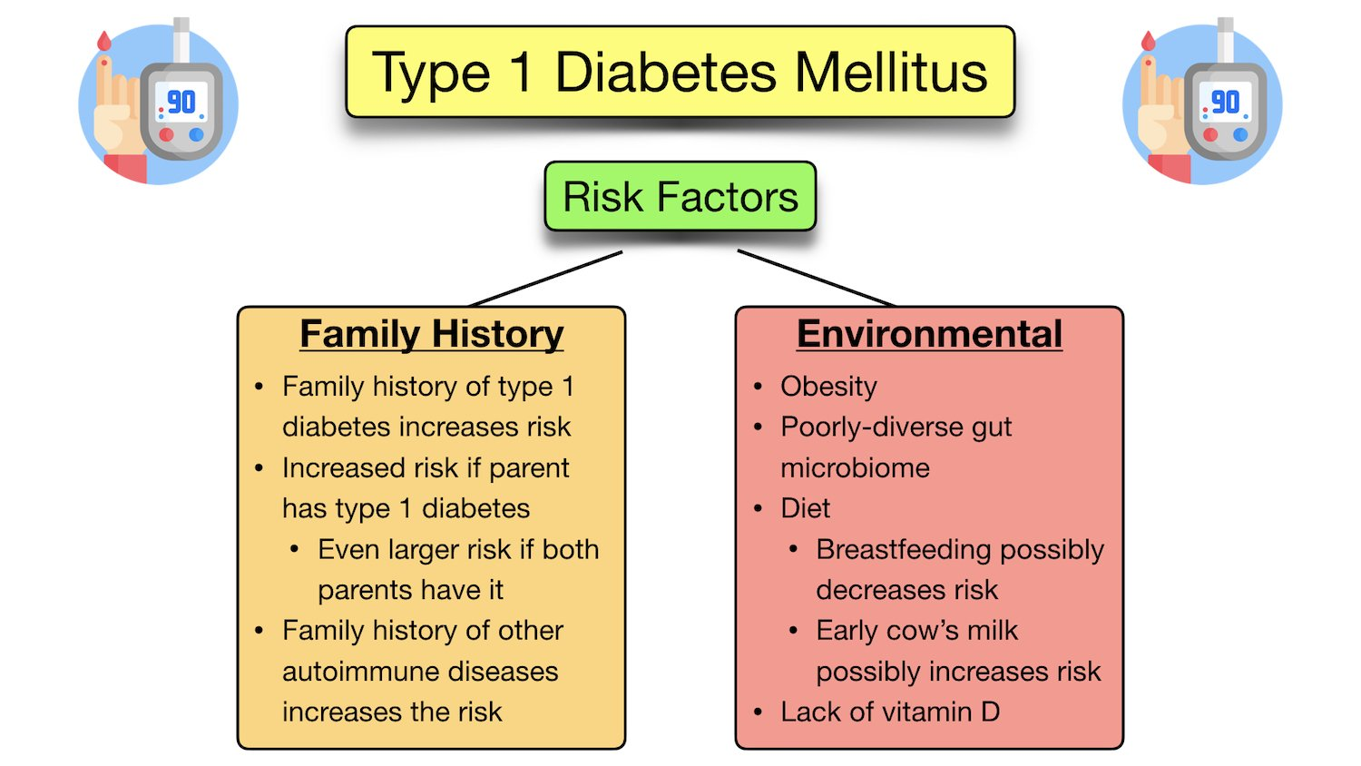

**Anatomy of the Pancreas**

In order to better understand the cause and pathophysiology of type 1 diabetes, let’s briefly review the anatomy and function of the pancreas and insulin.

The pancreas is an accessory organ of the abdomen.

The pancreas is located behind the stomach in the epigastric and left hypochondriac regions of the abdomen.

Anatomically, the pancreas is located along the trans pyloric plane.

The trans pyloric plane is an imaginary line midway between the suprasternal notch (jugular notch) and the upper border of the pubic symphysis, at approximately the level of the L1 vertebrae.

The pancreas can be divided into 5 main parts:

1. Head
2. Uncinated Process
3. Neck
4. Body
5. Tail

The head of the pancreas sits within the curve of the duodenum, and the tail is located by the hilum of the spleen.

The pancreas (except for the tail) is retroperitoneal - This includes the head, neck, and body.

The tail of the pancreas is intraperitoneal.

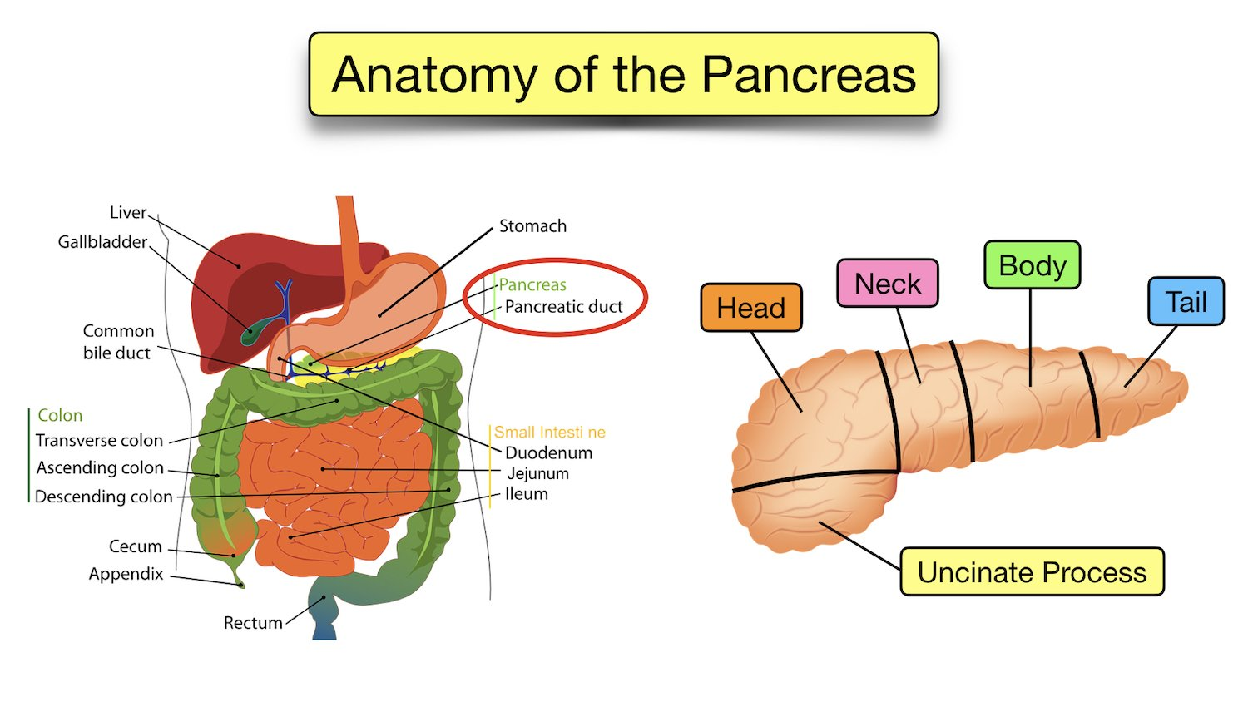

**Function of the Pancreas**

The pancreas has both exocrine and endocrine roles:

**Exocrine Function**

The pancreas produces digestive enzymes which are secreted into the duodenum via the main pancreatic duct.

Pancreatic digestive enzymes include lipase, amylase, and proteases (such as trypsin and chymotrypsin).

The pancreatic digestive enzymes aid in the digestion of fats (lipase), carbohydrates (amylase), and proteins (proteases).

**Endocrine Function**

The pancreas produces and secretes hormones into the bloodstream.

* Islets of Langerhans = Clusters of pancreatic endocrine cells that release specific hormones
  + Made up of 3 main types of cells:
    - Alpha Cells = Release glucagon
    - Beta Cells = Release insulin
    - Delta Cells = Release somatostatin

These hormones aid in glucose control.

The beta cells will be relevant in this lecture as they are responsible for producing and releasing insulin into the blood.

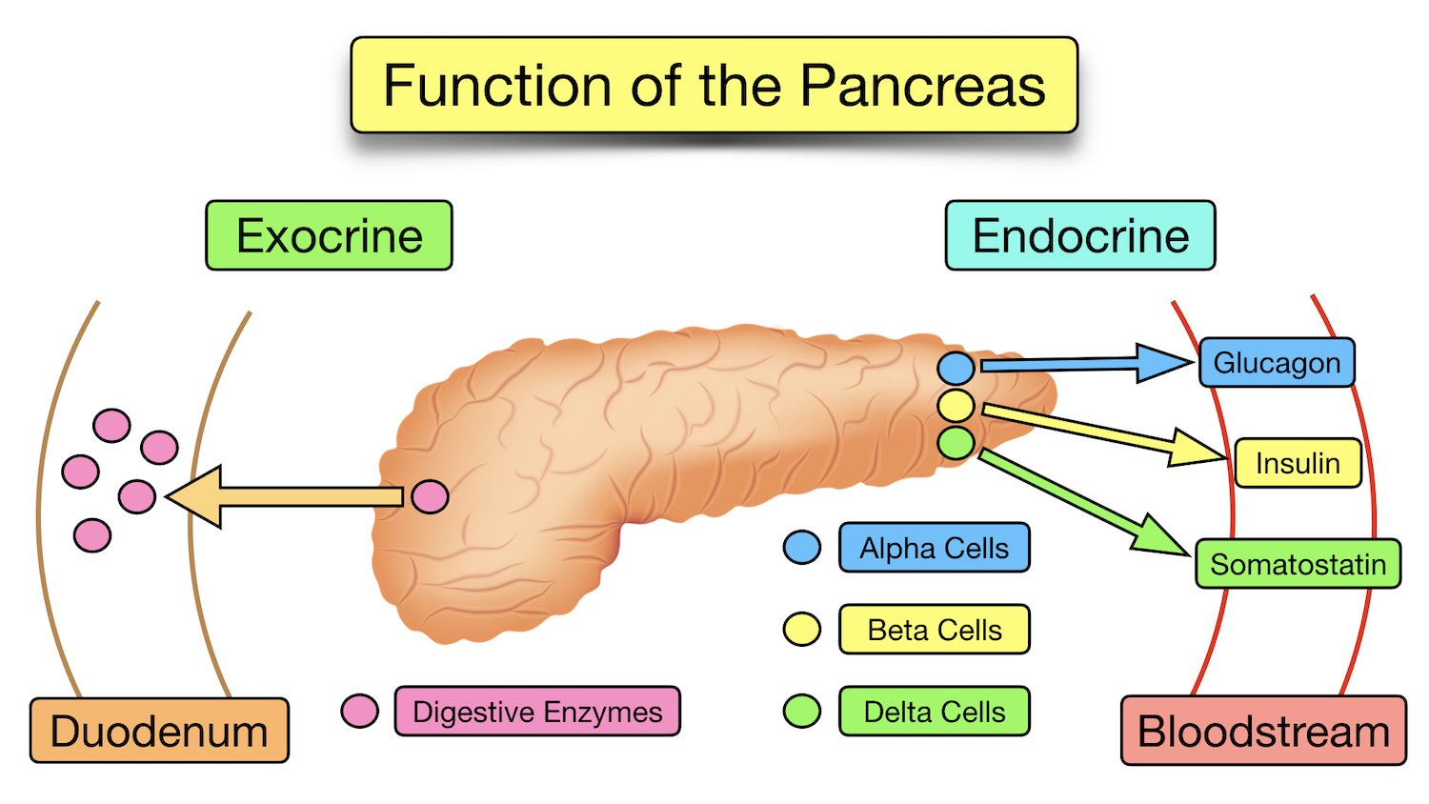

**Function of Insulin**

As previously mentioned, insulin is produced and released by the beta cells of the pancreas.

Insulin is responsible for regulating blood glucose levels in the body by allowing the movement of glucose into cells.

Insulin is continuously released by the pancreatic beta cells (see above) at a low level throughout the day, which helps to:

* Maintain the resting blood glucose levels at a healthy range between eating and during the night
* Allow constant low-level uptake of glucose into cells for cellular processes, such as cellular growth and DNA replication

Blood sugar rises after eating a meal, and the beta cells release insulin in a biphasic pattern.

* Firstly, beta cells rapidly release stored insulin from granules inside the cell
* Secondly, beta cells increase insulin synthesis for a smaller, second-phase release

How Does Insulin Work?

Once the beta cells of the pancreas release insulin into the blood, insulin binds to insulin receptors on the surface of body cells.

The binding of insulin to insulin receptors on cells activates a signalling cascade which increases the recruitment of the glucose transporter GLUT4 from intracellular storage vesicles to the plasma membrane.

GLUT4 is the major transporter responsible for the uptake of glucose from the bloodstream and into the cell.

An increase in GLUT4 glucose transporters at the plasma membrane will increase glucose uptake into the cell.

The cell can then use the glucose as energy or fuel to carry out its functions.

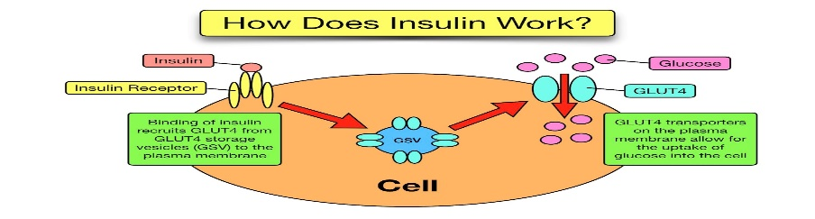

**Pathophysiology of Type 1 Diabetes**

Type 1 diabetes is an autoimmune condition in which the body’s immune system attacks its own pancreatic beta cells.

More specifically, the T-cells of the immune system destroy pancreatic beta cells in genetically predisposed individuals.

As previously mentioned, the beta cells are involved in producing, storing, and releasing insulin.

This autoimmune attack damages the beta cells, preventing them from producing or releasing insulin.

Without insulin, glucose cannot be taken up from the bloodstream into cells (see above).

This results in elevated blood glucose levels called hyperglycaemia.

The kidneys excrete the excess blood glucose into the urine, which can be detected as glycosuria (also called glycosuria) on a urine dipstick - More on this below!

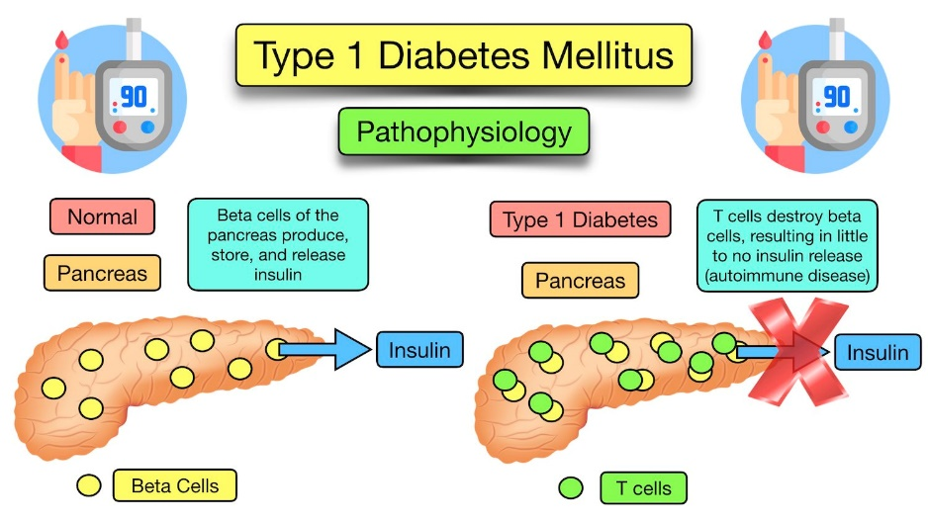

**Type 1 Diabetes Pathophysiology:** Type 1 diabetes is caused by an autoimmune process in which the T cells (green) destroy the insulin-producing beta cells (yellow) of the pancreas

**Diagnosis & Tests**

Diagnosis of type 1 diabetes involves measuring blood glucose levels through one of the following methods:

* Haemoglobin A1C
* Random blood sugar test
* Fasting blood sugar test

**Haemoglobin A1C**

Haemoglobin A1C (HbA1c) is a simple blood test that measures the patient’s average blood sugar levels over the past 2-3 months (8-12 weeks).

It measures the amount of blood glucose attached to haemoglobin (the protein in red blood cells that carries oxygen).

An A1C level of 6.5% or higher on 2 separate occasions suggests diabetes.

**Random Blood Sugar Test**

A blood sample can also be taken at random to assess a patient’s blood sugar level.

Regardless of when the last meal was, a blood glucose level of 200 mg/dL (11.1 mmol/L) or higher could be suggestive of diabetes.

**Fasting Blood Sugar Test**

A blood sample can also be taken after a period of fasting (usually overnight since midnight) to assess the blood glucose level.

Fasting blood glucose levels can be interpreted as:

* Less than 100 mg/dL (5.6 mmol/L) = Normal
* 100-125 mg/dL (5.6-6.9 mmol/L) = Prediabetes
* 126 mg/dL (7 mmol/L) or higher on 2 separate tests = Diabetes

**Pathophysiology of Type 1 Diabetes**

Type 1 diabetes is an autoimmune condition in which the body’s immune system attacks its own pancreatic beta cells.

More specifically, the T-cells of the immune system destroy pancreatic beta cells in genetically predisposed individuals.

As previously mentioned, the beta cells are involved in producing, storing, and releasing insulin.

This autoimmune attack damages the beta cells, preventing them from producing or releasing insulin.

Without insulin, glucose cannot be taken up from the bloodstream into cells (see above).

This results in elevated blood glucose levels called hyperglycaemia.

The kidneys excrete the excess blood glucose into the urine, which can be detected as glycosuria (also called glycosuria) on a urine dipstick - More on this below!

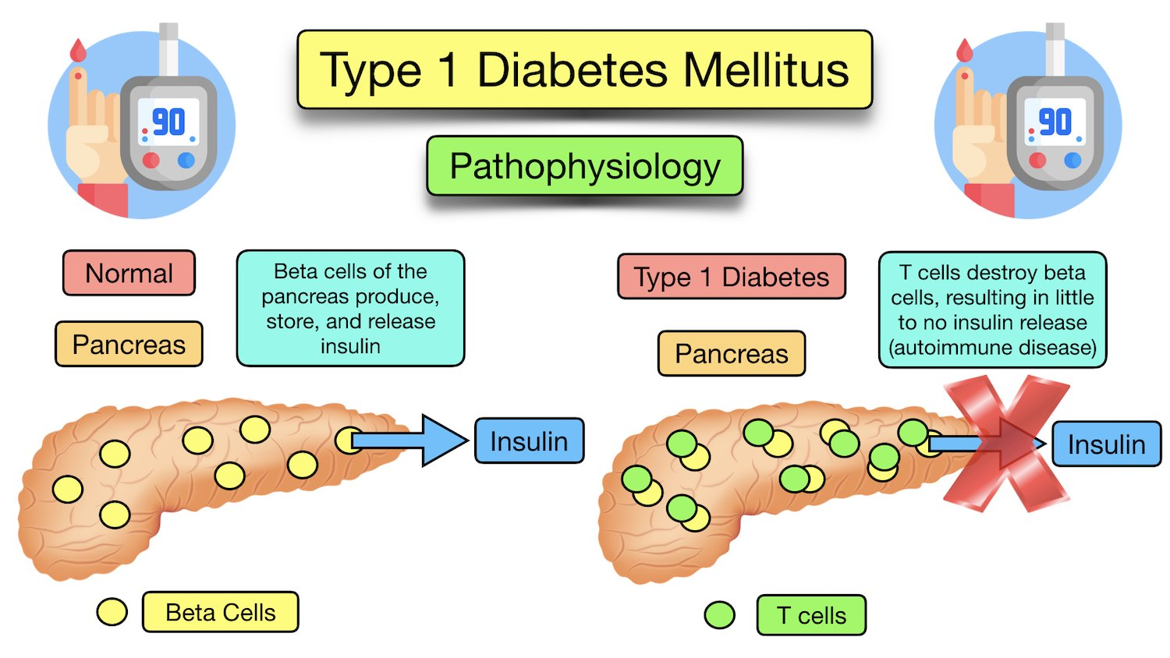

**Type 1 Diabetes Pathophysiology:** Type 1 diabetes is caused by an autoimmune process in which the T cells (green) destroy the insulin-producing beta cells (yellow) of the pancreas

**Diagnosis & Tests**

Diagnosis of type 1 diabetes involves measuring blood glucose levels through one of the following methods:

* Haemoglobin A1C
* Random blood sugar test
* Fasting blood sugar test

**Haemoglobin A1C**

Haemoglobin A1C (HbA1c) is a simple blood test that measures the patient’s average blood sugar levels over the past 2-3 months (8-12 weeks).

It measures the amount of blood glucose attached to haemoglobin (the protein in red blood cells that carries oxygen).

An A1C level of 6.5% or higher on 2 separate occasions suggests diabetes.

**Random Blood Sugar Test**

A blood sample can also be taken at random to assess a patient’s blood sugar level.

Regardless of when the last meal was, a blood glucose level of 200 mg/dL (11.1 mmol/L) or higher could be suggestive of diabetes.

**Fasting Blood Sugar Test**

A blood sample can also be taken after a period of fasting (usually overnight since midnight) to assess the blood glucose level.

Fasting blood glucose levels can be interpreted as:

* Less than 100 mg/dL (5.6 mmol/L) = Normal
* 100-125 mg/dL (5.6-6.9 mmol/L) = Prediabetes
* 126 mg/dL (7 mmol/L) or higher on 2 separate tests = Diabetes

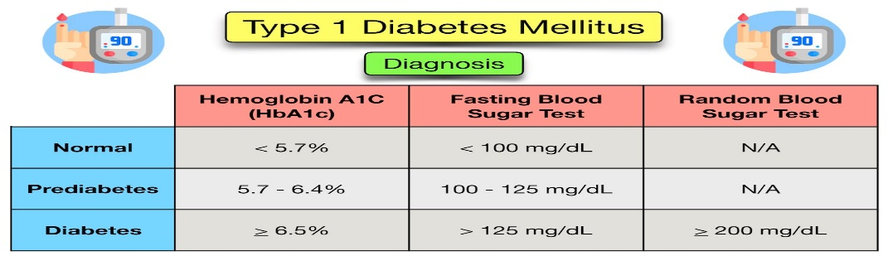

**Type 1 Diabetes Treatment**

The treatment and management of type 1 diabetes involves the following:

1. Education
2. Insulin
3. Careful Glucose Monitoring

Some patients who have diabetes that is difficult to control may be referred for islet cell or pancreas transplants.

**1. Education**

Patient education is an important part of managing type 1 diabetes.

As previously mentioned, the pancreas produces little to no insulin in type 1 diabetes (see above).

As a result, patients with type 1 diabetes must take insulin so glucose can be transported from the blood and into cells.

Not only does the patient need to take insulin, but they must know how much.

This requires education.

Patients require an understanding of carbohydrates and glucose, so they know how much insulin they will require with meals and/or throughout the day.

Patients will be offered educational programs where they are trained on carbohydrate counting to allow self-management of their diabetes.

The training will allow the patient to independently calculate and inject the correct amount of insulin for their meal, as well as provide corrective doses if required.

Due to the increased cardiovascular risk associated with type 1 diabetes, the educational programs may also offer dietary, exercise, and lifestyle advice.

Annual reviews will also offer guidance (see annual review below).

**2. Insulin**

Insulin therapy is the main treatment for type 1 diabetes.

This makes sense as the pancreas is unable to produce insulin.

There are different types of insulin that can be administered, and they vary on their onset, peak, and duration.

* Onset = How quickly insulin lowers blood sugar
* Peak = When insulin is at maximum strength
* Duration = How long insulin works to lower blood sugar

The main types of insulin include:

* Rapid-Acting
  + insulin aspart (NovoLog), insulin lispro (Humalog)
* Short-Acting
  + human regular (Humulin R)
* Intermediate-Acting
  + NPH (Humulin N)
* Long-Acting
  + detemir (Levemir), glargine (Lantus)
* Ultra-Long Acting
  + glargine U-300

**Premixed insulin is also available, which combines intermediate and short-acting insulin.

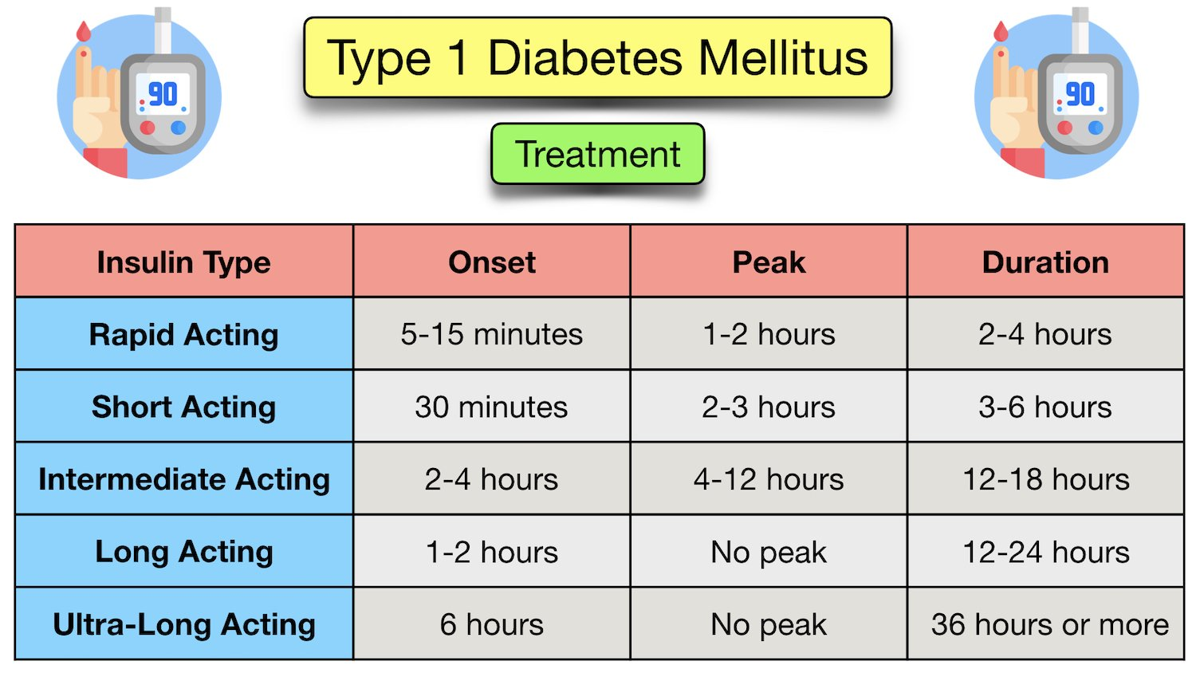

**Type 1 Diabetes Treatment:** Chart showing types of insulin (rapid acting, short acting, intermediate acting, long acting, and ultra-long acting) and their onset, peak, and duration.

Patients will be offered basal-bolus insulin regimens when first diagnosed.

Basal-bolus regimens involve multiple daily injections of a rapid or short acting bolus insulin administered before meals, and an intermediate or long acting insulin injection once or twice daily.

A combination of different length preparations are given in this regimen in order to mimic the normal physiological insulin release, and to maintain a stable glycaemic (blood glucose) level throughout the day.

Insulin is administered subcutaneously typically in the:

* Abdomen
* Outer Thigh
* Back of the Upper Arm
* Hip
* Upper Buttocks

Patients should be provided with a sharps bin to collect the used needles and related sharps.

The site of injection should be rotated regularly in order to prevent breakdown of fat beneath the skin (lipodystrophy/lipoatrophy).

Some patients prefer to use an insulin pump, allowing a continuous infusion of basal insulin, and bolus doses released at meal times, controlled by the patient.

**3. Glucose Monitoring**

It is important to monitor blood glucose levels to make sure they are appropriately managed.

**Haemoglobin A1C**

Haemoglobin A1C (HbA1c) levels should be measured by primary care staff every 3 to 6 months.

As previously mentioned, HbA1c is a simple blood test that measures the patient’s average blood sugar levels over the past 2-3 months (8-12 weeks).

A patient with type 1 diabetes should aim for a HbA1c of 6.5% (48 mmol/mol) or lower, in order to decrease the risk of cardiovascular disease, retinopathy, renal disease, etc.

**Self-Monitoring**

Patients are also expected to self-monitor their blood glucose levels.

This can be done in a variety of ways including:

1. Capillary glucose testing
2. Real time continuous glucose monitoring
3. Intermittently scanned continuous glucose monitoring (flash monitoring)

**Capillary Blood Glucose Testing**

Capillary blood glucose testing is a way to self-monitor blood glucose levels.

It involves using a lancet to pinprick the finger in order to draw a small amount of blood onto a test strip.

The test strip can then be analysed by a handheld glucose monitor.

Testing should be done at least 4 times a day (before each meal and before bed).

Testing may need to be done more frequently in times of illness, or if there are recurring episodes of hypoglycaemia/hyperglycaemia.

**Real Time Continuous Glucose Monitoring and Intermittently Scanned Continuous Glucose Monitoring (Flash Monitoring)**

Both real time and flash continuous glucose monitors allow the patient’s blood sugar to be checked by a small sensor, rather than by pin pricking the fingers.

The sensor is worn all day and night, and allows the blood sugar levels to be read on a Bluetooth connected smartphone.

The real time monitor automatically syncs blood glucose readings to a mobile device throughout the day, whereas the flash device requires the phone to ‘scan’ a sensor on the skin to take the blood glucose reading.

Even with a continuous glucose monitor, the patient must still check their capillary glucose levels regularly to ensure their device recordings are accurate.

**Blood Glucose Targets**

Blood glucose targets are seen below:

* Fasting glucose of 90-126 mg/dL (5-7 mmol/L)
* Plasma glucose level of 72-126 mg/dL (4-7 mmol/L)
* Aim for plasma glucose level of 90-162 mg/dL (5-9 mmol/L), 90 minutes after eating

**Annual Review**

Patients with diabetes in the UK will be invited to an “annual review” with a member of the multidisciplinary team at their primary care practice.

This will involve a full screen of the patient’s diabetic history, how they are managing their diabetes, and a full examination.

The examination will involve measuring the patient’s weight, abdominal circumference, and BMI (body mass index) to assess cardiovascular risk.

A full cardiovascular and peripheral vascular exam will also be completed, along with inspection of injection sites, the feet, and blood tests to check kidney function.

The patient must also be seen in a yearly eye clinic to check for diabetic retinopathy.

Urinalysis will also be done to check for ketones and glucose in the urine.

**Sick Day Rules**

A patient with type 1 diabetes must abide by what are known as “sick-day rules”.

Stress, such as acute illness, increases the level of cortisol produced and released by the adrenal glands.

This causes the blood glucose levels to increase without increased oral intake.

The patient must continue with their normal insulin regimen and check their blood sugar levels more frequently.

Ketones in the blood should also be checked, as there is an increased risk of diabetic ketoacidosis (DKA) when the patient is sick.

If the blood sugar is higher than expected when given their normal insulin dose, a corrective dose must be given.

**Complications of Type 1 Diabetes**

Complications of type 1 diabetes occur when blood glucose levels are not managed correctly.

**Short Term Complications**

Short term complications of type 1 diabetes include hypoglycaemic and hyperglycaemic episodes:

**Hypoglycaemic Episodes**

* Hypoglycaemic episodes can occur as a result of:
  + Too much insulin is given for the meal that was eaten
  + Too much insulin was given in the setting of recent exercise
    - Exercise can increase insulin sensitivity
    - Less insulin may be needed

**Hyperglycaemic Episodes**

* Hyperglycaemic episodes can occur as a result of:
  + Not enough insulin is given for the meal that was eaten
  + Non-compliance to the insulin regime
  + Diabetic Ketoacidosis (DKA)
    - When blood sugar levels are too high for too long
    - Leads to a build up of ketones in the body
    - Leads to hyperglycaemia and acidosis
    - Serious complication
    - Often requires hospital admission

**Long Term Complications**

Long term complications of uncontrolled type 1 diabetes can cause a range of microvascular and macro vascular complications including:

* **Microvascular** (related to small blood vessels)
  + Small blood vessels can become damaged by the sustained inappropriately high blood sugar
  + This can lead to:
    - Diabetic Retinopathy (Eyes) - May cause loss of vision in both eyes
    - Diabetic Nephropathy (Kidneys) - May require dialysis
    - Diabetic Neuropathy (Nerves) - Diabetic peripheral neuropathy has a high mortality rate due to infection
* **Macro vascular** (related to large blood vessels)
  + High blood sugar can cause plaque formation in blood vessels
  + This can increase the risk of:
    - Cardiovascular Disease
    - Heart Attack (Myocardial Infarction)
    - Stroke
    - Peripheral Vascular Disease (PVD)

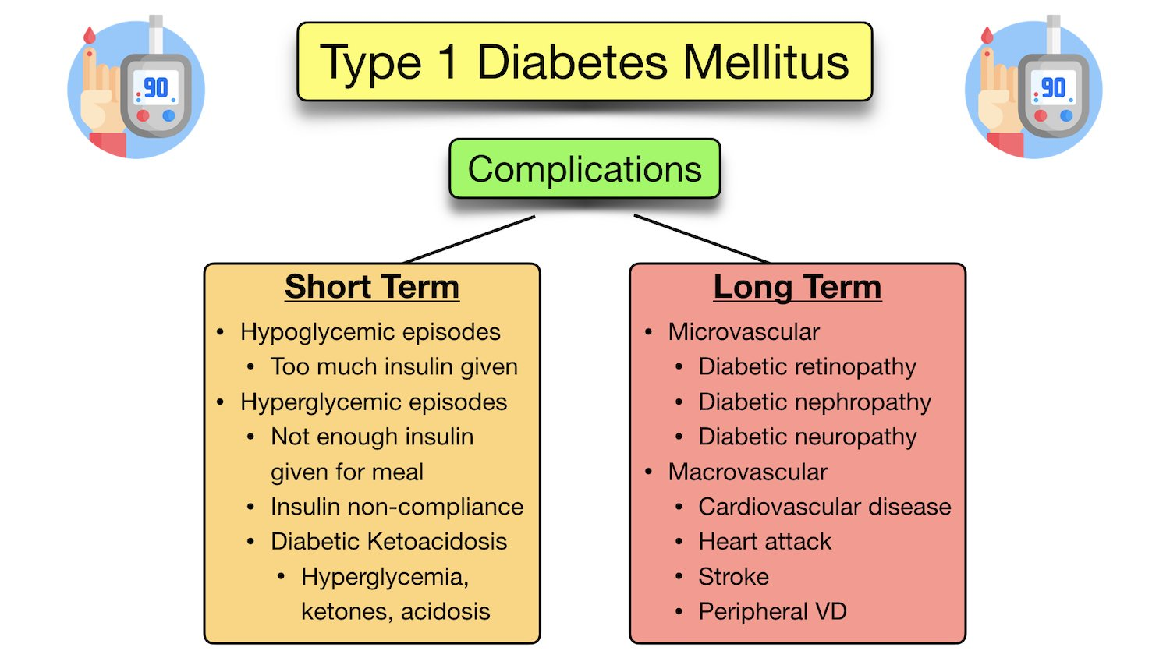

**Type 1 Diabetes with Disordered Eating (T1DE)**

It is worth being aware of the implications of a patient with type 1 diabetes withholding their insulin injections.

Type 1 diabetes with disordered eating (T1DE), also known as diabulimia, is an eating disorder in which patients with type 1 diabetes stop taking insulin in order to lose weight.

T1DE may also be associated with other eating disorder behaviours as well.

T1DE puts the patient at great risk of developing diabetic ketoacidosis and other diabetic complications described above.

Therefore, it is vital to identify patients with T1DE and provide the support they need.

References:

Oram R.; Understanding the Extremely Early Onset of Type 1 Diabetes; University of Exeter Medical School; Jan 2017 - March 2024; Accessed Feb 2023; https://www.diabetes.org.uk/research/our-research-projects/south-west/understanding-the-extremely-early-onset-of-type-1-diabetes

Ferri F.F.; Ferri’s Clinical Advisor 2023, E-Book; Elsevier Health Sciences; Last Updated 2022; Accessed Feb 2023; https://www.clinicalkey.com/student/content/book/3-s2.0-B9780323755733002687

CDC; Living with Diabetes - Managing Sick Days; Centers for Disease Control and Prevention; Last Reviewed Feb 2022; Accessed Feb 2023; https://www.cdc.gov/diabetes/managing/flu-sick-days.html

Rad A., Osika A.; Pancreas; Kenhub; Last Reviewed July 2022; Accessed Feb 2023; https://www.kenhub.com/en/library/anatomy/the-pancreas

Sapra A., Bhandari P.; Diabetes Mellitus; NIH National Library of Medicine; National Center for Biotechnology Information; StatPearls Publishing; Last Updated June 2022; Accessed Feb 2023; https://www.ncbi.nlm.nih.gov/books/NBK551501/

Nicholson E., May NG., Kar P.; Type 1 Diabetes; BMJ Best Practice; BMJ Publishing Group Ltd 2023; Last Updated Jul 2021; Accessed Feb 2023; https://bestpractice.bmj.com/topics/en-gb/25/history-exam#riskFactors

Diabetes UK; Type 1 Diabetes; Accessed Feb 2023; https://www.diabetes.org.uk/diabetes-the-basics/types-of-diabetes/type-1

Diabetes UK; Technology and Diabetes; Accessed Feb 2023; https://www.diabetes.org.uk/guide-to-diabetes/diabetes-technology

Smith-Marsh D., Zeller W.P.; Type 1 Diabetes Complications; Endocrine web; Last Updated Jan 2017; Accessed Feb 2023; https://www.endocrineweb.com/conditions/type-1-diabetes/type-1-diabetes-complications

Diabetes UK; Diabulimia and Diabetes; Accessed Feb 2023; https://www.diabetes.org.uk/guide-to-diabetes/life-with-diabetes/diabulimia

NICE; Diabetes - Type 1; NICE Clinical Knowledge Summaries (CKS); Last Updated Jan 2023; Accessed Feb 2023; https://cks.nice.org.uk/topics/diabetes-type-1/

Johns Hopkins Medicine; The Pancreas; Accessed Feb 2023; https://www.hopkinsmedicine.org/health/conditions-and-diseases/the-pancreas

American Diabetes Association; Insulin Basics; Accessed Feb 2023; https://diabetes.org/healthy-living/medication-treatments/insulin-other-injectables/insulin-basics

CDC; Types of Insulin; Centres for Disease Control and Prevention; Last Reviewed Dec 2022; Accessed Feb 2023; https://www.cdc.gov/diabetes/basics/type-1-types-of-insulin.html